**Big Idea:** God’s grace provides hope, which produces faith and love in those who understand it.

**Purpose Then:** Encouragements from the spread of the gospel in and around them.

**Call now:** Know that the gospel is still powerful and at work.

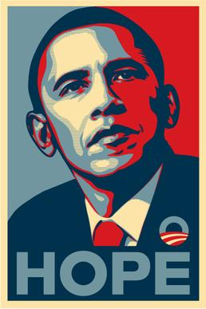**Observation, Understanding, and Application**

* HOOK: When running for president in 2008, Barack Obama produced a simple poster which showed a stylised picture of his face, with the word ‘hope’ emblazoned below. What is it about hope that made this such a powerful image?
  + *We recognise that hope is powerful, and that people draw hope from many different places. The fact is that the gospel provides an ultimate hope, and so has great power for all time and for all people.*
* In this passage, Paul talks a bit about hope.
  + What is the effect of the hope he talks about?
    - What is the relation between hope, and faith and love?
  + Where does the hope itself come from?
  + What does it mean for the hope to be ‘stored up in heaven’?
  + What’s different about this hope, and the hope people might put in a political leader?
* So why does Paul thank God for the people’s faith and love?
* How did the Colossians learn about this hope?
  + From the true message of the gospel (v5)
    - How does the gospel produce hope?
  + Which they heard from Epaphras (v7)
    - Where did Epaphras hear about the gospel?
* And beyond Colosse, what else is the gospel doing?
  + What does it mean for the gospel to be ‘bearing fruit and growing’?
    - *This isn’t something specific to them, but the work of the gospel in all the world.*
* Bringing this together, what is the pattern we see for how the gospel spread and transformed people in the 1st century AD?
  + Revelation to Paul (and apostles) -> Passed on by Epaphras -> People Hear -> Learn of Hope, Understand grace of God -> Produces Faith and Love
* Today we can’t go and speak to Paul or have Epaphras pass on what he said. How do people continue to learn about the gospel?
* What does this passage tell us about the work of the gospel in our own lives?
* What does this passage tell us about our role in the work of the gospel?